IGAD BIODIVERSITY MAPPING

Background

Biodiversity maps convey Land cover information about sites, distribution and extents of natural habitats that are repositories of biological diversity and which also provide raw material for natural selection and adaptation. Biodiversity generally refers to diversity in the variety of life or variability in genetic composition of life in an ecosystem. This variability in variety in an ecosystem provides a myriad of services for the habitats and enriches and sustains human life with both tangible and intangible economic and social goods. Derived biodiversity maps are a base as to the choice for watershed fortification and maintenance measures to be undertaken biological resource analysis, and other environmental degradation mitigation choices.
IGAD Region is one of the most biologically diverse regions in the world and includes parts of Eastern and the Horn of Africa.
The region’s biodiversity is also extremely important for the economy as well as the well-being of its people. Most of the IGAD Region population is rural dwellers, many of whom depend on a variety of agricultural, forest, and pastoralist products for their livelihoods.

IGAD Biodiversity Mapping Project Objectives
A need to understand the interrelationship between the land use/cover changes and degradation of the natural ecosystem to an extent that they are no longer able to meet their ecological and economic functions is among the major objectives of IGAD Biodiversity Mapping.
The IGAD Biodiversity Mapping project also required compilation of National Spatial Dataset that are used to generate national land cover and vegetation type maps for three epochs 2003, 2010 and 2017.The derived change maps will theninformthelevel ofbiodiversitydegradationfor possible interventionandrestorations. It should be noted here that this project had other players who are specialist in diverse fields among them biodiversity, agro-ecologists, tools developers etc. RCMRD was exclusively contracted to undertake land cover change mapping and provide a data base through which further analysis can be based.

RCMRD’s role
RCMRDwas contracted since its mission of promotingsustainabledevelopmentthrough generation,application anddisseminationofGeo-InformationandalliedICTservices andproducts intheMemberStates and beyond” resonated well with the IGAD Biodiversity Mapping project requirements.RCMRD has also participated (i.e.in some of the countries of the region) in land use/landcovermapping,changedetection, the GreenHouseGases(GHG)mapping, Establishment of Forest Observatory,hazardandfloodriskmapping, agro-ecologicalzonation and capacitybuildingandtraining.The intended landuse/landcoverchangemapsof IGADRegionare expectedto beamongthe toolsinplanninganddecisionmaking.
Methodology and data choice
The choice of data and methodology was agreed based on Letter, “Ref.Aed-400/”datedofMay2016and further discussionand confirmation byIGAD senior staff. The data of choice is remotelysensed Landsat data; epochs2003,2010and2017 and the focus is onlandcoverchangeanalysis of the three epochs.
Djibouti being one the IGAD member countries is one of the stake-holders in the Biodiversity project. The images have already beenprocessed through supervised classification with a Maxim-likelihood Algorithm. Land cover classes chosen for delineation are forest, shrubland, cropland, urban, grassland, water bodies and wetland.
The groundtruthingdata collection activity (still on-going) is meant to collect in-situ data inform of GPS coordinates, Photographs and descriptions of the preselected ground sample sites generated after supervised classification. Some of the points will improve on classification results, validate the existing cover class types while others will be for accuracy assessment.
CERD is collaborating with RCMRD in the ground truthing exercise. The field points sites selected for validation and accuracy assessment have considered the size of Djibouti, geographical orientation as well as the land cover classes obtained from supervised classification.
It is regrettable that some of the points in the north through the Day forest and the Khor-Anger mangrove forest will not be visited due to security concerns and the lengthy permit approvals that would take several days and therefore boggle down this attempt. We however request CERD, (our partner in the ground truth validation exercise) to consider collecting the remaining data in the North and further consider sharing this data with us as this will further strengthen our shared vision for data sharing and mutual collaboration on activities that are of importance to RCMRD and CERD.

Thedeliverableswillbeintheformof land cover maps, change maps, matrixofchanges analyzed, reportsandrelatedstatisticaldata. IGAD has also been requested to sponsor a capacity trainingofstaffofthegovernmentorganization.
The field points selected for validation accuracy assessment have considered the size of Djibouti, geographical orientation as well as the land cover classes obtained from supervised classification.
It is regrettable that some of the points in the north through the Day forest and the Khor-Anger mangrove forest will not be visited due to security concerns and the lengthy permit approvals that would take several days that the team from RCMRD did not have. We however request CERD, (our partner in the ground truth validation exercise) to consider collecting the remaining data in the North and further consider sharing this data with us as this will further strengthen our shared vision for data sharing and mutual collaboration on activities that are of importance to RCMRD and CERD.

Acknowledgements
This ground validation field mission would not have been possible were it not for the immense support provided by the CERD and we take this early opportunity to thank Dr. Jalludin Mohamed (Director General CERD) who not only hosted us in his office but candidly shared Djibouti’s specific needs and choice of scale in regional mapping projects, as Djibouti has a much smaller size compared to other countries in the Region. Dr. Jalludin also provided his staff to accompany us in the field. To this respect, we extend our gratitude to MadhiDjamaRayaleh (Laboratoire National de la Cartographie Centre d’Etude et de Recherche de Djibouti) and Ing.MohamedEguehWalleh (agro-pedologue&Environnementaliste Centred’Etude et de Recherche de Djibouti).
Special thanks go to IGAD Secretariat and the Biodiversity Mapping Team for sponsoring this project and having confidence in RCMRD to deliver the project’s objectives and deliverables. In this regard, we would like to thank Dr. DebalkewBerhe for his support and coordination and his introduction to CERD Institute.

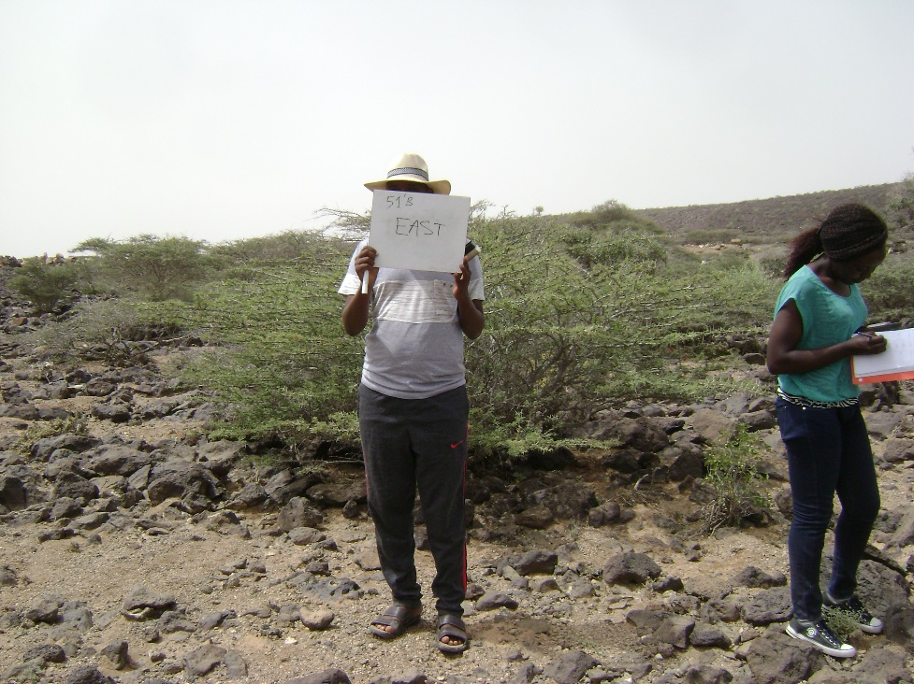
Fig1. Field data documentation-Open shrubland

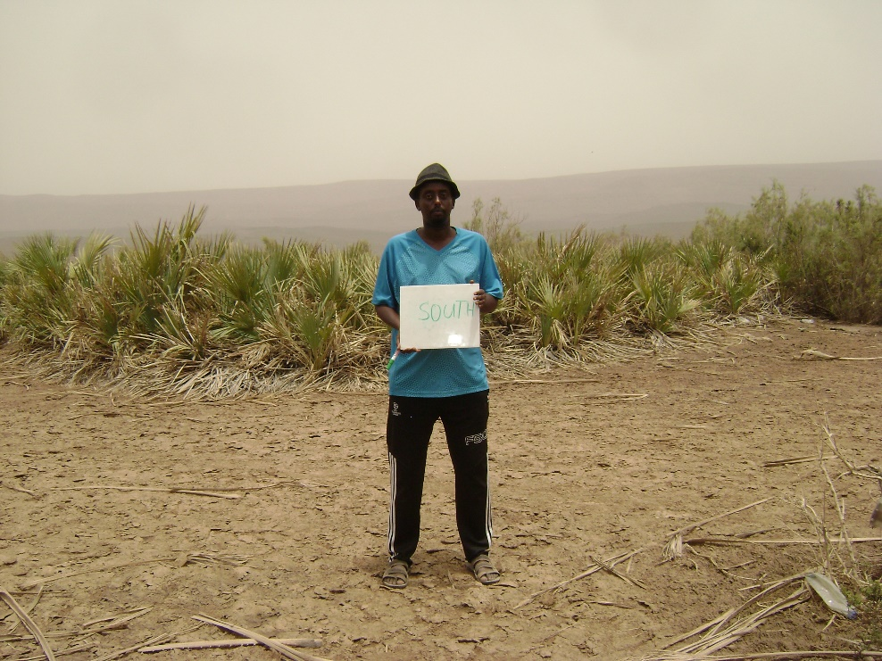
Fig2. Field data documentation-Closed shrubs on wetland

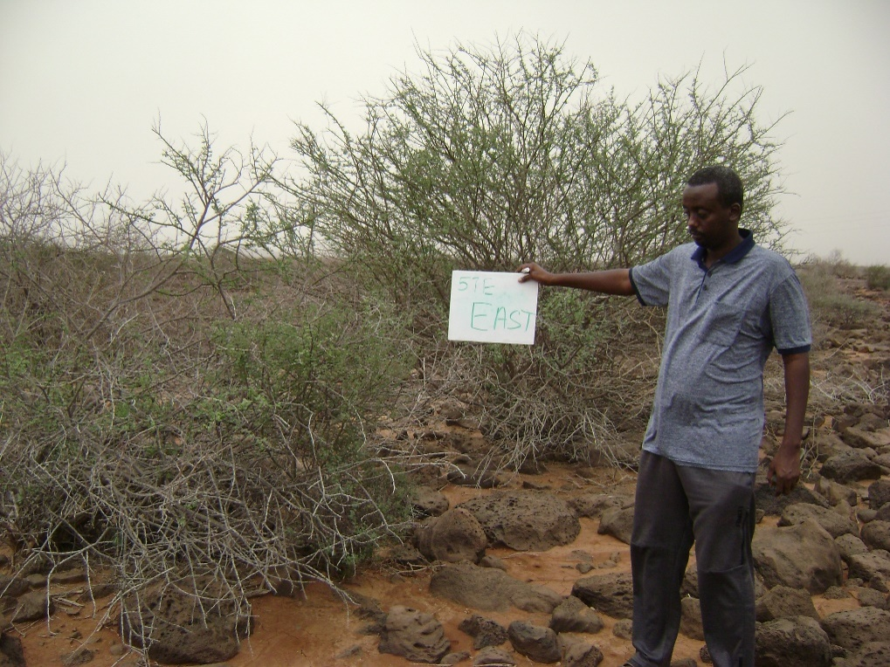

Fig3. Field data documentation-closed shrubland; Acacia Prosopis
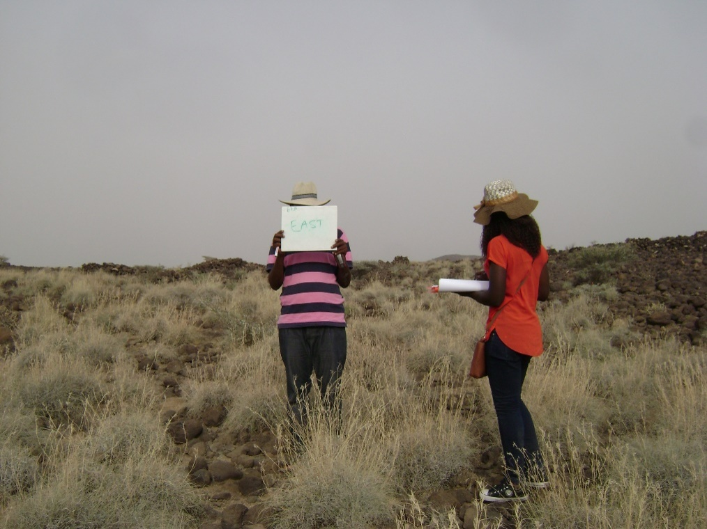
Fig4. Field data documentation-Grassland

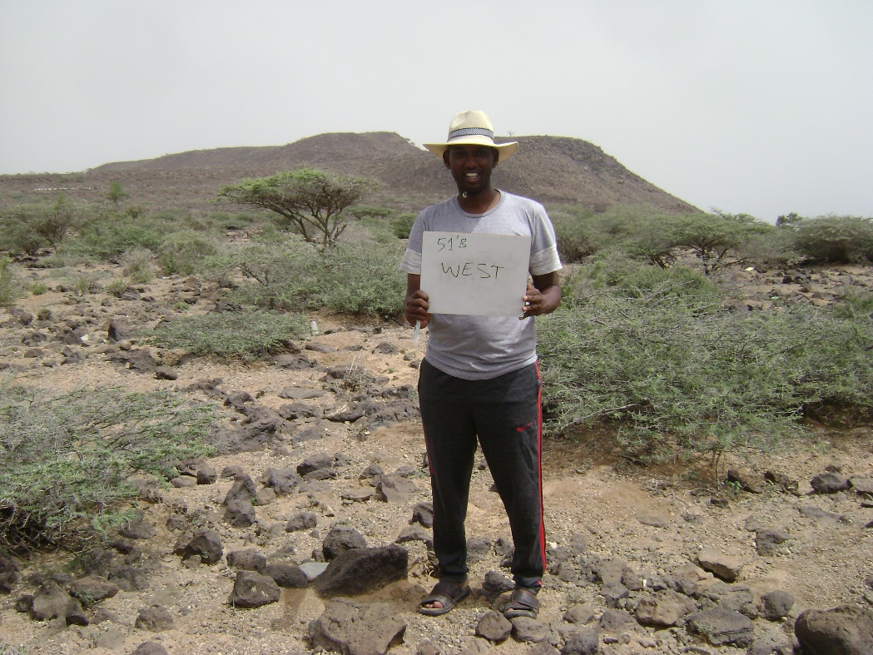
Fig5. Field data documentation-open shrubland; Acacia Prosopis

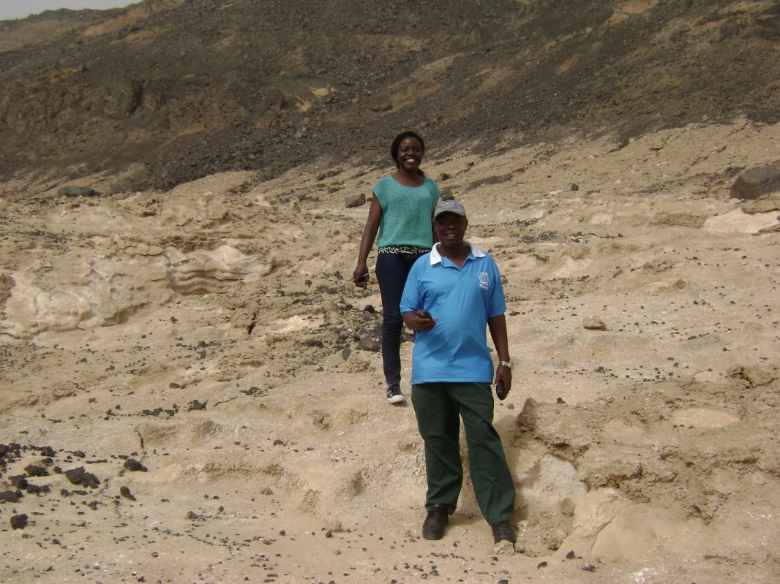
Fig6. Field data documentation-RCMRD data collection team

